**Bluetooth Module HC-05**

Introduction

* It is used for many applications like wireless headset, game controllers, wireless mouse, wireless keyboard and many more consumer applications.
* It has range up to <100m which depends upon transmitter and receiver, atmosphere, geographic & urban conditions.
* It is IEEE 802.15.1 standardized protocol, through which one can build wireless Personal Area Network ([PAN](https://en.wikipedia.org/wiki/Personal_area_network)). It uses frequency-hopping spread spectrum ([FHSS](https://en.wikipedia.org/wiki/Frequency-hopping_spread_spectrum)) radio technology to send data over air.
* It uses serial communication to communicate with devices. It communicates with microcontroller using serial port (USART).

HC-05 Bluetooth Module

* HC-05 is a Bluetooth module which is designed for wireless comunication. This module can be used in a master or slave configuration.

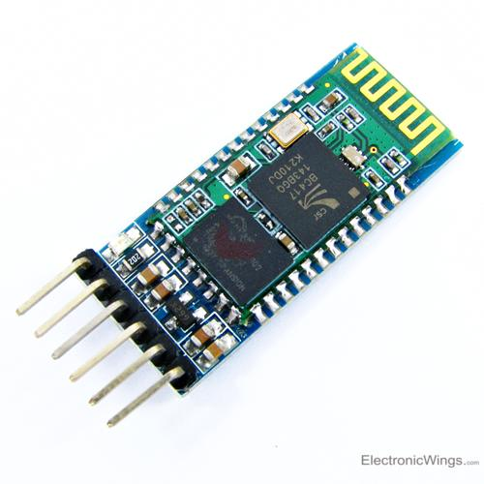

**HC-05 Bluetooth Module**

Pin Description

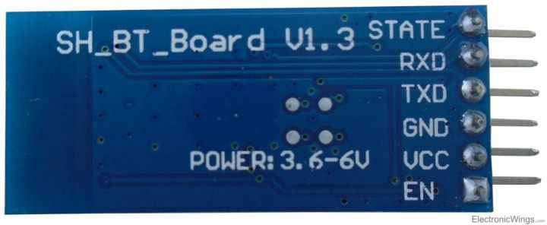

Bluetooth serial modules allow all serial enabled devices to communicate with each other using Bluetooth.

It has 6 pins,

1.  **Key/EN:** It is used to bring Bluetooth module in AT commands mode. If Key/EN pin is set to high, then this module will work in command mode. Otherwise by default it is in data mode. The default baud rate of HC-05 in command mode is 38400bps and 9600 in data mode.

HC-05 module has two modes,

          1.  **Data mode:**Exchange of data between devices.

          2.  **Command mode:**It uses AT commands which are used to change setting of HC-05. To send these commands to module serial (USART) port is used.

2.  **VCC:**Connect 5 V or 3.3 V to this Pin.

3.  **GND:**Ground Pin of module.

4.  **TXD:**Transmit Serial data (wirelessly received data by Bluetooth module transmitted out serially on TXD pin)

5.  **RXD:** Receive data serially (received data will be transmitted wirelessly by Bluetooth module).

6.  **State:**It tells whether module is connected or not.

**HC-05 module Information**

* HC-05 has red LED which indicates connection status, whether the Bluetooth is connected or not. Before connecting to HC-05 module this red LED blinks continuously in a periodic manner. When it gets connected to any other Bluetooth device, its blinking slows down to two seconds.
* This module works on 3.3 V. We can connect 5V supply voltage as well since the module has on board 5 to 3.3 V regulator.
* As HC-05 Bluetooth module has 3.3 V level for RX/TX and microcontroller can detect 3.3 V level, so, no need to shift transmit level of HC-05 module. But we need to shift the transmit voltage level from microcontroller to RX of HC-05 module.

Command Mode

* When we want to change settings of HC-05 Bluetooth module like change password for connection, baud rate, Bluetooth device’s name etc.
* To do this, HC-05 has AT commands.
* To use HC-05 Bluetooth module in AT command mode, connect “Key” pin to High (VCC).
* Default Baud rate of HC-05 in command mode is 38400bps.
* Following are some AT command generally used to change setting of Bluetooth module.
* To send these commands, we have to connect HC-05 Bluetooth module to the PC via serial to USB converter and transmit these command through serial terminal of PC.

|  |  |  |
| --- | --- | --- |
| **Command** | **Description** | **Response** |
| AT | Checking communication | OK |
| AT+PSWD=XXXX | Set Password  e.g. AT+PSWD=4567 | OK |
| AT+NAME=XXXX | Set Bluetooth Device Name  e.g. AT+NAME=MyHC-05 | OK |
| AT+UART=Baud rate, stop bit, parity bit | Change Baud rate  e.g. AT+UART=9600,1,0 | OK |
| AT+VERSION? | Respond version no. of Bluetooth module | +Version: XX OK  e.g. +Version: 2.0 20130107   OK |
| AT+ORGL | Send detail of setting done by manufacturer | Parameters: device type, module mode, serial parameter, passkey,etc. |